Olympiáda v anglickom jazyku – školské kolo, kategória 1A

**READING COMPREHENSION**

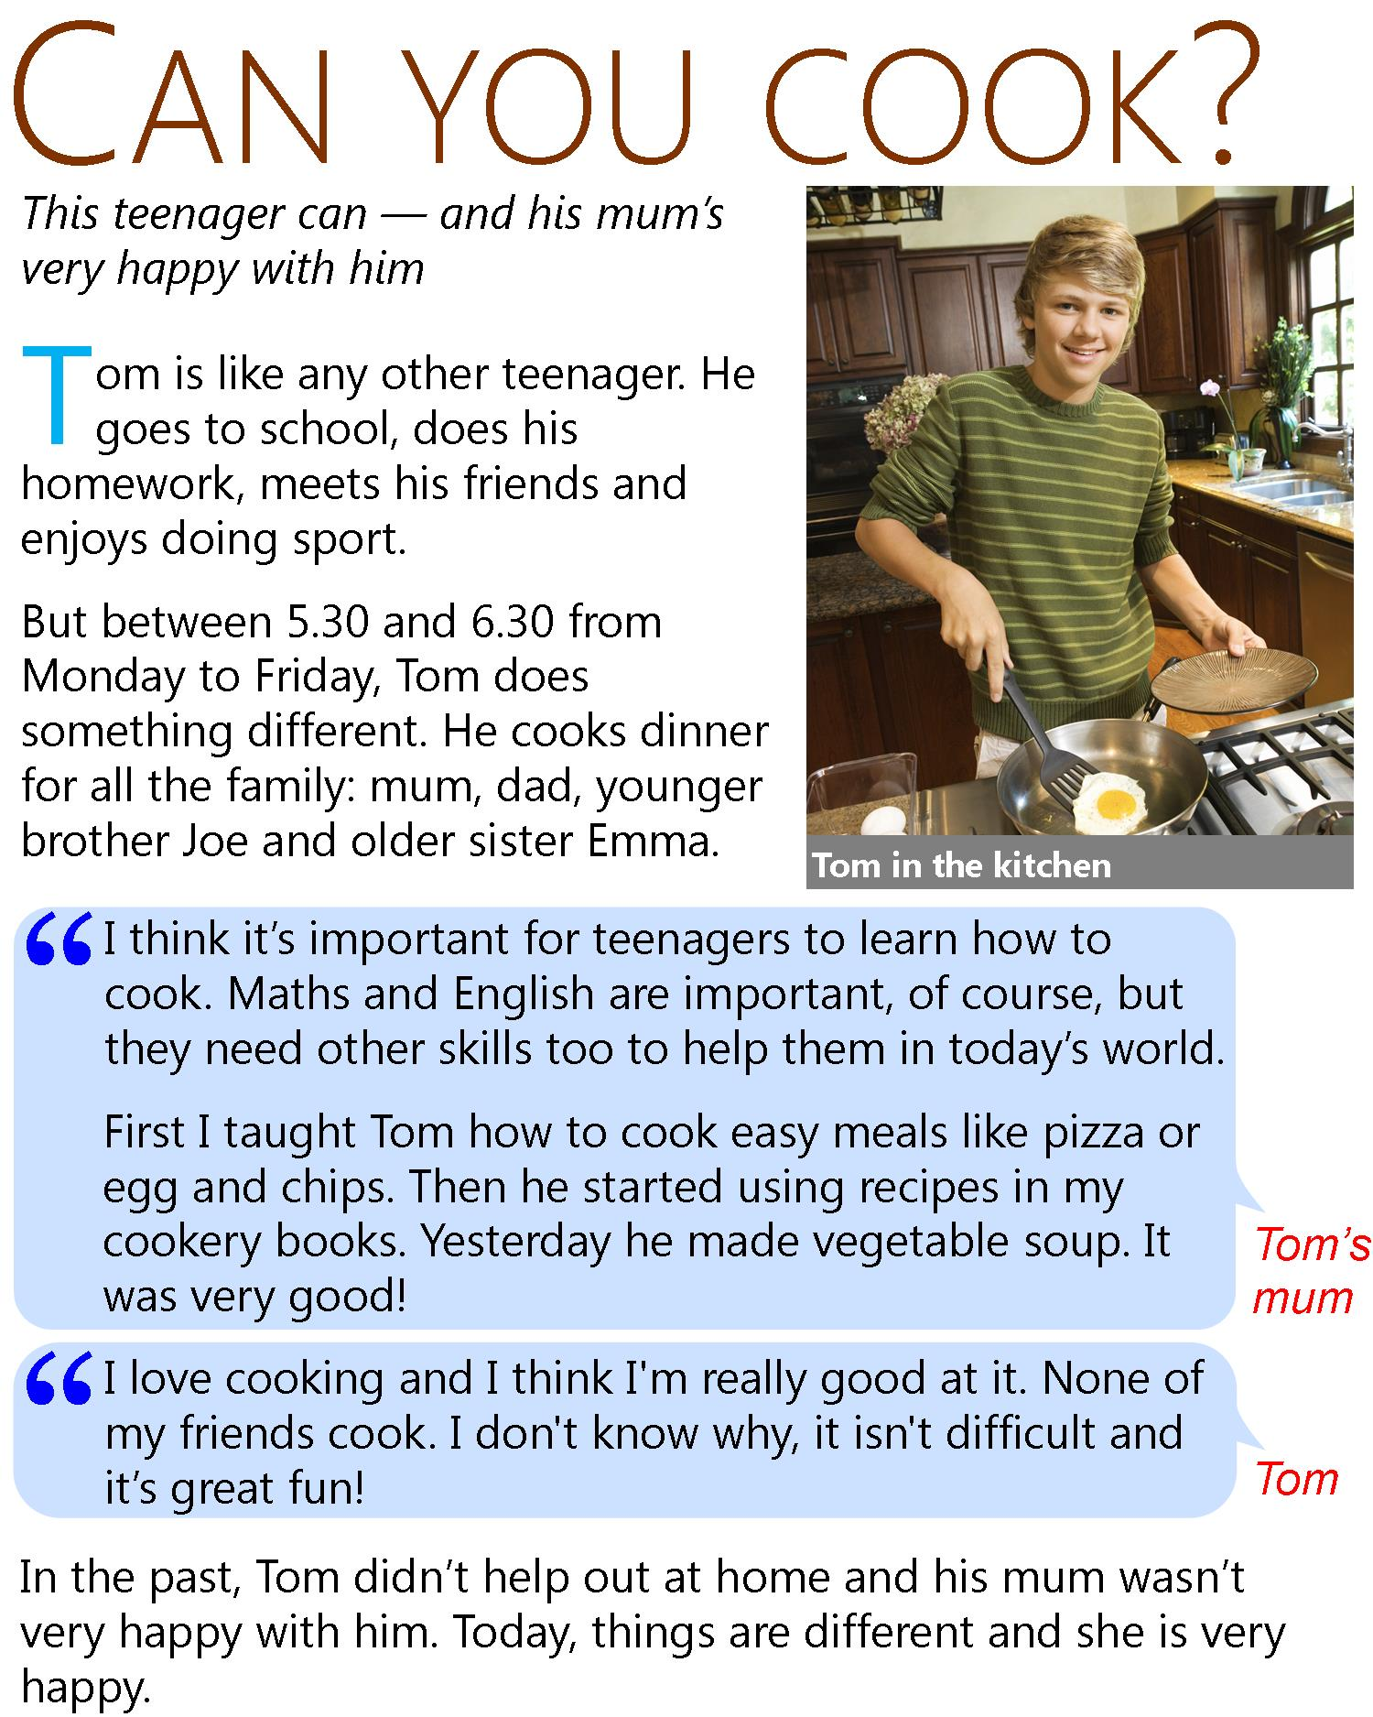

**Are the sentences true or false?**

1. Tom does one thing that teenagers don't normally do. T F
2. Tom doesn’t do homework, because he cooks. T F
3. Tom is the only person who eats the food he cooks. T F
4. Tom's mum was happier when he didn't cook. T F
5. Tom's mum thinks learning to cook is good for teenagers. T F
6. Tom learned some recipes from his grandmother. T F
7. Tom's vegetable soup was not good. T F
8. Tom says he is a good cook. T F
9. Tom's friends like cooking now, too. T F
10. Tom helped at home in the past, too. T F

Olympiáda v anglickom jazyku – školské kolo, kategória 2A

**READING COMPREHENSION**

# **A travel guide Bangkok**

**Where to stay**

The Khao San Road was a famous traveller spot even before Leonardo di Caprio's character in the film The Beach stayed there. But it's noisy, not very pretty and not very Thai. For something more authentic, Phra Kanong offers an alternative place to stay, with its fantastic street markets where everyday Bangkok people eat, work and live.

**How to get around**

Bangkok's traffic can be a nightmare. Sure, you can easily take a taxi – if you want to spend hours stuck in traffic jams – but there are two much better ways to get around the city. To explore the temples and historical sites, catch an express boat river taxi or a longtail boat along the Chao Phraya river and the canals. For the modern part of the city, the Skytrain is a fast, cheap way to travel from the river to the shopping malls and nightlife of Sukhumvit, and the famous Chatuchak street market.

**Where to eat**

The simple answer is: everywhere! Thai street food is among the best in the world. Some food stands have little plastic seats where you can sit and eat and they cook the same dish over and over, like fried chicken on rice or Pad Thai noodles. Head for Chinatown – Yaowarat Street – and choose whatever looks most interesting from the many excellent Chinese and Thai restaurants and food stands.

**What to do**

After you've seen the main sites like the Giant Buddha at the temple of Wat Pho and the spectacular Grand Palace, and shopped at Chatuchak market, check out the snake farm and watch the live snake show. You can even touch a snake yourself if you want to!

**CHOOSE CORRECT ANSWER**



1. a place that you might see in the film 'The Beach' ................................
2. a place where local Thai people go ................................
3. an alternative route through the city ................................
4. a place to go for shopping and bars ................................
5. a place to go for food ................................
6. place of the Giant Buddha ................................
7. Khao San Road is a pretty historical street. T F
8. Khao San Road is an authentic Thai area of the city. T F
9. The river boat taxis often get stuck in traffic too. T F
10. You need to choose where to eat carefully, as not everywhere is good. T F
11. Začiatok formulára
12. Spodná časť formulára
13. Spodná časť formulára
14. Spodná časť formulára
15. Spodná časť formulára

Olympiáda v anglickom jazyku – školské kolo, kategória 1B

**READING COMPREHENSION**

# **Choosing a conference venue**

### **The International Centre**

Whether you are looking for a conference venue or a place to have your meetings and your training days, the International Centre is the perfect modern space for your event.

Offering free Wi-Fi, secure parking and all-day refreshments, the International Centre has 120 meeting rooms and a theatre for up to 1,000 people.

Conveniently located in the city centre, the International Centre is close to the shops and only a ten-minute walk to the train station.

### **The Grand West**

The Grand West is a country house surrounded by rolling hills and beautiful scenery, only a 30-minute drive from the airport.

With 76 hotel rooms, 12 meeting rooms and a conference room that takes up to 200 people, the Grand West offers free Wi-Fi and a whiteboard in every room.

You can also make use of the gardens of the Grand West for team-building events and outdoor activities. Our indoor swimming pool, gym and 18-hole golf course will ensure that your event is relaxing and enjoyable for everyone.

**CHOOSE CORRECT ANSWER**

1.If you need a large conference venue for about 600 people, you should book the International Centre.

T F

Začiatok formulára

Spodná časť formulára

2. If you want to go shopping after your meetings, you should book the Grand West. T F

Začiatok formulára

Spodná časť formulára

3. Only the International Centre offers free Wi-Fi. T F

Začiatok formulára

Spodná časť formulára

4. If you go to a conference at the International Centre, you can have food and drink any time during the

day. T F

Začiatok formulára

Spodná časť formulára

5. You can have fun playing golf if you go to an event at the Grand West. T F

Začiatok formulára

Spodná časť formulára

6. You have to walk for 30 minutes if you want to go from the Grand West to the airport.

T F

**WRITE ANSWERS**

7. Name 2 room types: ................................... and ......................................

8. Name 2 facilities that these venues offer: ................................... and ......................................

9. Name 2 events that are offered to visitors: ................................... and ......................................

10. Name 2 sports that people can do here: ................................... and ......................................

Olympiáda v anglickom jazyku – školské kolo, kategória 2B

**READING COMPREHENSION**

### **Ronan**

I work in a fairly traditional office environment doing a typical nine-to-five job. I like my job, but it's annoying that my commute to work takes an hour and a half each way and most of my work could really be done online from home. But my boss doesn't seem to trust that we will get any work done if left to our own devices, and everyone in the company has to clock in and out every day. It's frustrating that they feel the need to monitor what we do so closely instead of judging us based on our task performance, like most companies do these days.

### **Jo**

I used to do a typical five-day week, but after I came out of my parental leave, I decided that I wanted to spend more time with my children before they start school. After negotiating with my boss, we decided to cut my working week down to a three-day work week. This of course meant a significant cut in my pay too, as I'm paid on a pro-rata basis. I've since noticed, though, that my workload hasn't decreased in the slightest! I'm now doing five days' worth of work in three days, but getting paid much less for it! I find myself having to take work home just so that I can meet the deadlines. It's wearing me out trying to juggle work with looking after my children and my family, but I don’t dare to bring this up with my boss because I think he feels as if he's made a huge concession letting me come in only three days a week.

### **Marcus**

I work for a global IT company, but because their headquarters is in the States, I do all my work online from home. That means that I don't waste time commuting or making idle chit-chat with colleagues. I work on a project basis, and this flexibility is very valuable to me because it means that I can easily take some time off when my children need me to go to their school performances or if I need to schedule an appointment with the dentist. The downside is that without clear office hours, I tend to work well into the evening, sometimes skipping dinner to finish a task. It can also get quite lonely working on my own, and I sometimes miss sharing ideas with colleagues.

**CHOOSE CORRECT ANSWER**

1.Ronan's boss thinks his employees will not be as productive if they work from home.

T F

Začiatok formulára

Spodná časť formulára

2. Ronan thinks that the performance of employees should be judged according to how much time they spend in the office. T F

3. Ronan’s job is interesting because of travelling possibilities. T F

Začiatok formulára

Spodná časť formulára

444. Jo is paid the same for a five-day work week as she is on a three-day work week.

T F

Začiatok formulára

Spodná časť formulára

55. Jo feels exhausted trying to manage both a five-day workload and childcare. T F

Začiatok formulára

Spodná časť formulára

55566. Jo’s boss agreed to reduce her working hours. T F

7. Marcus works for the American company. T F

8. Although Marcus sees the benefit in not having idle chit-chat, he misses interacting with his colleagues.

T F

9. Marcus sees the advantage in not having office hours. He may work at night when he needs to finish his work. T F

10. Marcus’s flexibility is a positive thing for a person with family. T F

Spodná časť formulára

Olympiáda v anglickom jazyku – školské kolo, kategória 1A

**LISTENING COMPREHENSION**

**Booking a table**

Zdroj: <https://learnenglish.britishcouncil.org/skills/listening/a1-listening/booking-a-table>

**Staff**: Hello, Gino's.

**Jamie**: Hi. Can I book a table for tomorrow night, please?

**Staff**: How many people is it for?

**Jamie**: Four.

**Staff**: And what time would you like?

**Jamie**: About eight, eight thirty maybe?

**Staff**: Let's see ... We're pretty busy tomorrow, so I can do half past seven or nine.

**Jamie**: Oh. OK, then. Half seven, please.

**Staff**: What name is it?

**Jamie**: Jamie.

**Staff**: J-A- ...?

**Jamie**: M-I-E

**Staff**: OK, so that's a table for four at half past seven tomorrow evening.

**Jamie**: Great. Thanks! Bye.

**Staff**: Bye.

**Staff**: Hello, Gino's.

**Jamie**: Hi, I called earlier to book a table for four and I was wondering if I can make it for six instead?

**Staff**: Ah, what name was it?

**Jamie**: It's Jamie.

**Staff**: Table for four at half past seven. So you want to change it to 6 o'clock?

**Jamie**: No, sorry. Can I make it for six people?

**Staff**: Oh, I see. Sorry! That shouldn't be a problem. I can move you to a bigger table but it will be nearer the kitchen. Is that OK?

**Jamie**: No problem. Is it possible to change the time as well? Make it a little bit later?

**Staff**: Ah ... yeah, we can. Is eight OK for you?

**Jamie**: Perfect, thanks!

**Staff**: Lovely. See you tomorrow, then.

**Jamie**: Thanks! Bye!

**Staff:** Thanks. Ciao!

Olympiáda v anglickom jazyku – školské kolo, kategória 1A

**LISTENING COMPREHENSION**

**ANSWER THE QUESTIONS:**

1. What’s the name of the restaurant? ...................................
2. When is the tabled booked for? ...................................
3. What time is the first booking? ...................................
4. Is it possible to change the booking? ...................................
5. How many people are finally comming? ..................................

Olympiáda v anglickom jazyku – školské kolo, kategória 1B

**LISTENING COMPREHENSION**

Zdroj: <https://learnenglish.britishcouncil.org/skills/listening/a2-listening/an-invitation-to-a-party>

**Automated message:** You have two new messages. Message number one, received today at 3.45 p.m.

Hi, it's me. How's it going? I guess you're at work and you don't have your phone on, right? First of all, thank you, THANK YOU for the birthday card and message. I received it this morning. That's so nice of you. I'm organising a little party for my birthday. It's nothing very big – only a few of my best and closest friends. That means you too! We're going to have it at my cousin's house. She lives in the countryside in a nice big house with a swimming pool. I'd love to see you there. It's going to be this Friday. I'll send you the instructions on how to get there later, OK?

Anyway, have fun at work. Don't work too hard, OK? Talk soon.

**Automated message:** You have two new messages. Message number two, received today at 5.15 p.m.

Aw, you're still not answering your phone! OK, here are the instructions to get to my cousin's house for the party. Are you going to take your car? If you take the car, drive straight on Forest Road until you get to the motorway. Drive past Brownsville and take exit 13A. That's 13A. You drive down the road there and turn left. It's the first big house on the right. OK? If you're taking a bus, you can get the number 80 to Brownsville. Call me when you get there and somebody can pick you up in a car. I can't wait. This is going to be so great!

Olympiáda v anglickom jazyku – školské kolo, kategória 1B

**LISTENING COMPREHENSION**

1. Who is the party for? ........................................................................
2. Where is the party? ........................................................................
3. Is the house in a big city? ........................................................................
4. When is the party? ........................................................................
5. Which exit she should take? ........................................................................

Olympiáda v anglickom jazyku – školské kolo, kategória 2A

**LISTENING COMPREHENSION**

**Student 1**: Sorry. Sorry, excuse me. I'm just … just coming to sit over here. Phew. Hey. How's it going? So, what have I missed?

**Student 2**: Nothing. He just started around five minutes ago.

**Student 1**: Did he say anything about the mid-term?

**Student 2**: What?

**Student 1**: About the mid-term tests. Did he say anything about when he was going to hand them back?

**Student 2**: He's almost finished marking them, he said. We get them next Tuesday.

**Student 1**: I'm sorry, I didn't catch that. When do we get them?

**Student 2**: Tuesday. Next Tuesday.

**Student 1**: OK. Got it. Sorry. What page are we meant to be on?

**Student 2**: Page 34.

**Student 1**: Page … 34. Oh, wait. I don't have my textbook. Can I … share with you? Wow. This is hard stuff.

**Student 2**: Mmm.

**Student 1**: What does SEO mean?

**Student 2**: What?

**Student 1**: SEO. This is all about SEO but he hasn't said what it means.

**Student 2**: Search engine optimisation. How to appear on internet searches.

**Student 1**: Internet searches. Right. Right. OK.

**Student 2**: He said what it meant.

**Student 1**: What?

**Student 2**: He explained it before you got here.

**Student 1**: Oh. Right. OK.

**Student 2**: Can you be quiet? I'm trying to listen to the lecture.

**Student 1**: So am I. Sorry. Sorry, one more question. What does this have to do with the American Revolution?

**Student 2**: What?

**Student 1**: I don't get it. Why is he talking about search engines in a course on the American Revolution?

**Student 2**: What are you talking about? This is a class on software engineering.

**Student 1**: You mean, it's not Early American History?

**Student 2**: You're in the wrong class.

**Student 1**: Oh, wow. Now it all makes sense. I'm so sorry.

**Student 2**: It's fine.

**Student 1**: Here, I'll just … excuse me. I'm in the wrong class. Excuse me. Thanks. Sorry.

Olympiáda v anglickom jazyku – školské kolo, kategória 2A

**LISTENING COMPREHENSION**

**ANSWER THE QUESTIONS**

1. When do students get back their tests? ...................................................
2. Which page are they working at the moment? ...................................................
3. What did the student forget? ...................................................
4. Which class the student should be in? ...................................................
5. Where is he right now? ...................................................